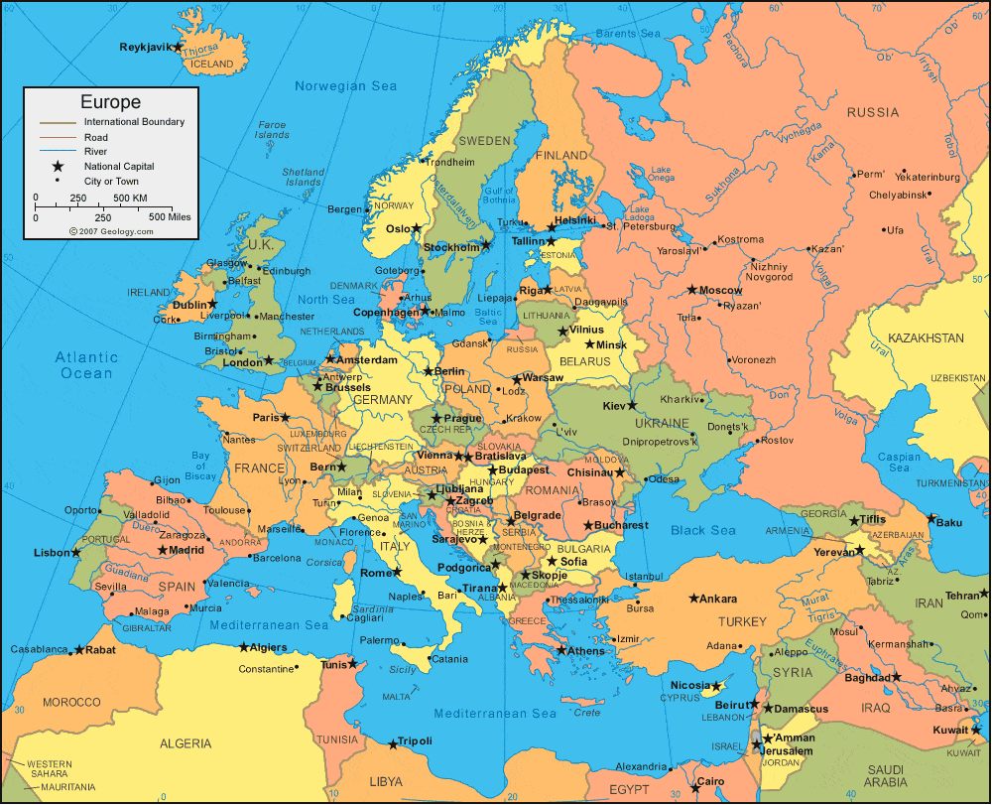

**Badgers Class Curriculum Plan**

**Spring Term 2023**